**Correct this paragraph with the word above instead of below:**

The TSA classifies "dangerous items" according to 16 categories, represented by the 16 images **above.** Select an item from the dropdown below to see how many times that item was found in each U.S. airport last year.

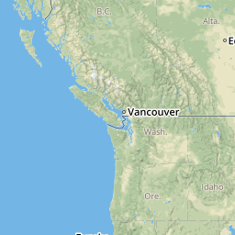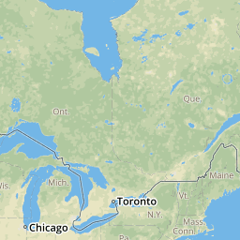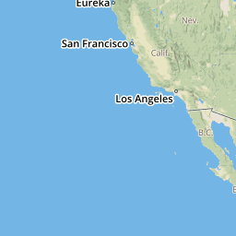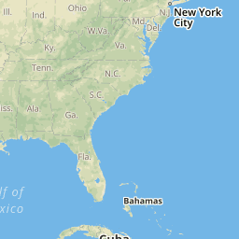

**Replace: jdfjdskfjdsfjdskffdfjkdjfkdf ndkfjkdjfkdsjfkd kdfkdfmkdnkfjdkfj dfjkdjfkdf**

**With this Paragraph:**

The airports with the most dangerous items confiscated are not always the ones with the most passenger traffic. Select airport from the dropdown below to see how many times that item was found in each U.S. airport last year.

INTERESTING FACTS:

In **Anchorage International Airport**, the 55th busiest U.S. airport by number of boarding passengers, the TSA confiscated 434 dangerous items last year. For comparison, in **LAX (Los Angeles International Airport)**, the second busiest U.S. airport with 14x the passenger traffic of Anchorage, the TSA confiscated just 199 dangerous items.

TSA screens more than 2 million passengers daily and over 750 million every year

• TSA screens 1.3 million checked items for explosives and other dangerous items daily

• TSA screens 4.9 million carry-on items for explosives and other prohibited items every day

• Responsible for the security of over 23,000 domestic flights per day

• Responsible for the security of nearly 2,800 outbound international flights per day